Project report on
Profit Plus

Undertaken at:
Sopra Steria Group, Noida
29 May 2026 - 22 July 2026
Submitted by: Vishal Kaushik  (Master of Computer Applications) | Under guidance of: Mr. Amit Gupta  (Senior Technical Manager)  Sopra Steria Group, Noida

Table of Contents
Acknowledgement i
Certificate ii
About Sopra Steria Group iii
Abstract iv
Hardware and Software Used v
Introduction 1
1.1 Purpose of Project 1
1.2 Scope of Project 2
2. System Design 4
2.1 Architecture Overview 4
2.1.1 External Entities: 4
2.1.2 Core Data Stores: 5
2.1.3 Major System Modules: 5
2.2 DIAGRAMS: 6
2.2.1 Gantt Chart 6
2.2.2 Level 0 DFD 7
2.2.3 Level 1 DFD 9
2.2.4 System Architecture Diagram 11
2.3 Database Design: 14
2.3.1 Tables: 17
2.4 Project Screenshots: 22
2.4.1 Signup and Login: 22
2.4.2 Log-in 23
2.4.3 Forgot password 24
2.4.4 Create Businesses 25
Setting Up a New Shop (Create Business) 25
2.4.5 My Businesses 26
2.4.6 Add Products 27
2.4.7 My Products 28
2.4.8 Manage Stocks 29
Restocking and Managing Inventory 29
2.4.9 Inventory 31
2.4.10 Billing 31
Creating a Sale (The Billing Counter) 32
2.4.11 Sale Confirmed 33
2.4.12 Subscription 33
Explain 34
2.4.13 Payment Gateway 35
2.4.14 Emi Management 36
Selling on EMI (Installment Payments) 36
2.4.15 Generated Bill on Mail 37
2.4.16 Sales History 38
2.4.17 Customer Records 38
Viewing Customer Profiles and History 39
2.4.18 Analytics Section: 40
Explain 40
Business Intelligence & Analytics Terminal 40
2.4.19 Shop Dashboard 42
Shop Manager (Business Dashboard) 42
2.4.20 Overview Stats 44
Super Admin Dashboard (Platform Growth) 44
2.4.21 User Management 45
Managing Platform Users (Admin Controls) 45
2.4.22 Registered Businesses 46
2.4.23 Revenue Analytics 47
2.4.24 Subscription Management 48
Managing Platform Subscriptions and Pricing 48
2.5 Test Table 49
2.6 Applications of the Project 51
3. Conclusion
4. Reference and Bibliography

Acknowledgement
I would like to express my deepest appreciation and sincere gratitude to my project guide, Mr. Amit Gupta, Senior Technical Manager, for his invaluable guidance, continuous encouragement, and constructive feedback throughout the development of the "Profit Plus" project. His mentorship has been instrumental in the successful completion of this project.
I would also like to extend my thanks to Sopra Steria Group, Noida, for providing me with this wonderful opportunity and the necessary resources to work on an enterprise-grade software solution. The experience gained during this period from 29 May 2026 to 22 July 2026 has been incredibly enriching and will undoubtedly help me in my future endeavors.

Certificate
This is to certify that the project report entitled "Profit Plus" is a bona fide record of the project work carried out by Vishal Kaushik under my supervision and guidance.
This project was undertaken at Sopra Steria Group, Noida, between 29 May 2026 and 22 July 2026 in partial fulfillment of the requirements for the degree of Master of Computer Applications. To the best of my knowledge, this work is original and has not been submitted elsewhere for the award of any other degree or diploma.

About Sopra Steria Group
Sopra Steria is a European leader in consulting, digital services, and software development. The group helps its clients drive their digital transformation and obtain tangible and sustainable benefits. Sopra Steria provides end-to-end solutions to make large companies and organizations more competitive by combining in-depth knowledge of a wide range of business sectors and innovative technologies with a fully collaborative approach.
With a strong presence in India, particularly in Noida, Sopra Steria plays a vital role in global delivery, offering high-value IT and business services while fostering a culture of innovation and excellence among its engineers and interns.

Abstract
Running a modern storefront or small business comes with a mountain of moving parts—tracking stock, handling billing, managing customer credit, and keeping an eye on daily profits. Profit Plus is a desktop-grade business management and Point-of-Sale (POS) application built to take the chaos out of day-to-day operations. At its core, the platform uses a smart multi-tenant architecture, meaning a single user account can comfortably manage multiple distinct businesses while keeping sensitive data—like inventory, customer lists, and sales records—completely isolated and secure.
Under the hood, the entire application runs on a pure Python stack. We split the architecture into two clean layers: a fast, asynchronous FastAPI backend handling all the RESTful API logic and database interactions, paired with a responsive Flet frontend that delivers a smooth, desktop-native user interface without needing clunky web technologies.
The software comes packed with practical features designed for real-world storefronts. It features a dynamic billing counter that calculates cart totals and applies taxes on the fly, automated stock checks to prevent selling items you don't have, and a built-in EMI tracker to handle customer installment plans and credit sales seamlessly. On top of that, business owners get a dedicated supplier management module and a powerful analytics dashboard that tracks key performance indicators (KPIs) like pure profit, net revenue, and sales volume. By bringing everything together into one unified workspace, Profit Plus acts as a complete, ready-to-run SaaS solution tailored to help local businesses grow.

Hardware and Software Used

Hardware Used
Component | Specification
Processor | Intel Core i7
Memory (RAM) | 16 GB RAM
Storage | 512 GB SSD disk space
Display | Minimum resolution of 1280x720

Software Used
Category / Tool | Technology Used
Programming Language | Python 3.9
Frontend Framework | Flet (Python-based Flutter framework)
Backend Framework | FastAPI
Database | PostgreSQL (Neon Cloud)
Authentication | JWT (JSON Web Tokens) with Passlib & bcrypt
Database Migrations | Alembic
Development Tools | Visual Studio Code, Git, Uvicorn (ASGI server)

Introduction
In today's fast-paced digital economy, small to medium-sized enterprises (SMEs) face significant challenges in efficiently managing their day-to-day operations. From tracking real-time inventory and managing supplier relationships to processing billing and analyzing sales trends, handling these processes manually or through fragmented software often leads to inefficiencies and data inconsistencies.
Profit Plus was conceptualized and developed to address these exact challenges. It is a unified Business Management and Point-of-Sale (POS) software designed to provide a cohesive, end-to-end solution for business owners.
The project leverages modern Python technologies. The backend is powered by FastAPI, ensuring high-speed asynchronous data processing and secure RESTful endpoints. The database interactions are optimized using SQLAlchemy 2.0. On the frontend, the application utilizes Flet to deliver a rich, real-time, desktop-grade graphical user interface (GUI) that requires no traditional web technologies like HTML or JavaScript, keeping the development purely native to Python.
Through features like automated stock deduction, EMI management for credit sales, and an insightful analytics dashboard, Profit Plus not only automates routine tasks but also provides actionable intelligence to help business owners make informed decisions. This report details the architecture, design, and implementation of Profit Plus as a comprehensive SaaS platform.

1.1 Purpose of Project
The main goal behind creating Profit Plus is to make life easier for small and medium-sized enterprises (SMEs). Running a business involves juggling a lot of moving parts, and handling processes manually or through fragmented software often leads to inefficiencies and data inconsistencies.
Profit Plus was built to address these exact challenges by bringing all essential operations into a cohesive, end-to-end solution. Specifically, the project aims to:
- Simplify Daily Operations: Provide a unified Business Management and Point-of-Sale (POS) software where business owners can manage everything from billing to supplier relationships seamlessly.
- Support Business Growth: Empower entrepreneurs who operate multiple storefronts or businesses to manage everything from a single, centralized account through a scalable multi-tenant architecture.
- Ensure Data Isolation: Keep critical data such as inventory, sales, and customer relations completely separate and secure for each individual business under that single account.
- Automate Routine Tasks: Take the manual work out of operations by including features like automated stock deduction, dynamic cart calculation, and EMI (Equated Monthly Installment) tracking for credit sales.
- Provide Clear Business Insights: Equip business owners with an insightful analytics dashboard that tracks key performance indicators (KPIs) and provides actionable intelligence for smarter decision-making.

1.2 Scope of Project
The scope of Profit Plus revolves around providing a complete, end-to-end toolkit for small and medium-sized enterprises (SMEs) to run their daily operations smoothly. Rather than just being a simple cash register, the system is built to handle the entire business lifecycle from a single application.
- Target Audience & Delivery: The platform is designed as a Software as a Service (SaaS) tailored specifically for modern SMEs. It provides a desktop-grade experience without requiring a complex web browser setup.
- Multi-Business Management: A major part of the project's scope is its multi-tenant architecture. This means an entrepreneur can manage several different stores or businesses using just one centralized account.
- Strict Data Isolation: Even though multiple businesses can be managed from one account, the system strictly separates critical data—meaning inventory, sales records, and customer lists for one store will never bleed into another.
- Core POS & Billing Features: The software includes an advanced billing system that calculates carts dynamically and handles automated stock validation to ensure inventory is always accurate.
- Credit & EMI Tracking: Recognizing that many businesses offer payment plans, the scope includes built-in tracking for Equated Monthly Instalments (EMIs), making it easy to manage credit sales.
- Supplier & Inventory Management: It handles the backend of the business too, allowing owners to easily manage supplier relationships and track real-time inventory levels.
- Analytics and Reporting: The scope extends beyond just collecting data; it includes a dedicated analytics dashboard that tracks key performance indicators (KPIs) to help business owners spot trends and make informed decisions.

2. System Design
The system design of Profit Plus is built around creating a seamless, scalable, and secure experience for business owners. Because it needs to handle everything from inventory to billing across multiple businesses, the architecture is divided into clear, manageable components.

2.1 Architecture Overview
Profit Plus operates on a scalable, multi-tenant architecture, meaning a single user account can manage multiple businesses completely independently. The system uses a purely Python-based technology stack divided into two main parts:
- Backend: A high-performance RESTful API powered by FastAPI, which handles all the heavy lifting, asynchronous data processing, and secure endpoints.
- Frontend: A responsive, desktop-grade graphical user interface (GUI) built with Flet, which keeps the development native to Python without needing HTML or JavaScript.
- Database: Data is managed using an SQLite database, optimized through the SQLAlchemy 2.0 ORM for secure and efficient queries.

2.1.1 External Entities: The system interacts with a few key actors and external services to function:
- System Administrator (Super Admin): Manages the overall platform, dynamic pricing, and user accounts.
- Business Owner (Tenant): The primary user who registers on the platform, manages their stores, handles billing, and tracks inventory.
- Customer & Supplier: The end-consumers making purchases and the vendors supplying the stock.
- External APIs: The system hooks into Razorpay for secure subscription payments and an external Email Service Provider (SMTP/API) for sending OTPs during registration and password resets.
2.1.2 Core Data Stores: To ensure strict data isolation and fast retrieval, the database is logically separated into several core modules:
- Users & Businesses DB: Stores user credentials, OTPs, roles, and individual business profiles with their subscription statuses (FREE vs. PRO).
- Products & Inventory DB: Holds the product catalogs (categories, barcodes, HSN codes) alongside real-time stock quantities and low-stock alerts.
- Sales & EMI DB: Records all completed bills, invoice PDFs, transaction modes, and credit sale installment schedules.
- Pricing Config: A dedicated JSON file/configuration that stores dynamic subscription pricing managed by the Super Admin.
2.1.3 Major System Modules: The functional processes of Profit Plus are broken down into the following key modules:
- Authentication & Security: Handles account creation using email OTPs and secures user sessions by issuing JWT (JSON Web Tokens) upon login.
- Point-of-Sale (POS) & Billing: Processes barcode scans or manual item selections, calculates dynamic totals and taxes, generates invoice PDFs, and automatically deducts sold items from the inventory.
- EMI & Credit Management: Registers credit sales by taking a down payment, calculating future monthly installment due dates, and logging partial payments.
- Subscription & Payments: Manages the upgrade path for Business Owners by generating an order through the Razorpay API, rendering a secure checkout page, and verifying the payment signature to unlock PRO features.

2.2 DIAGRAMS:
2.2.1 Gantt Chart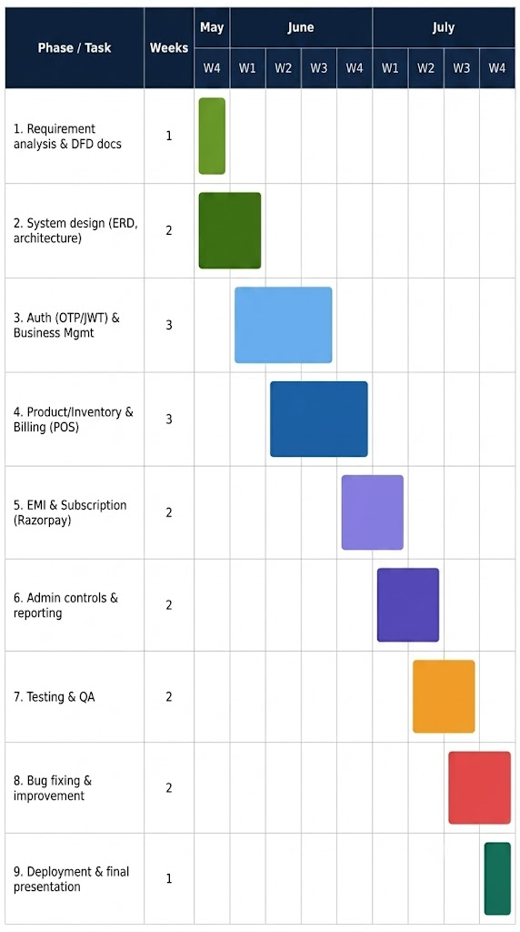

2.2.2 Level 0 DFD
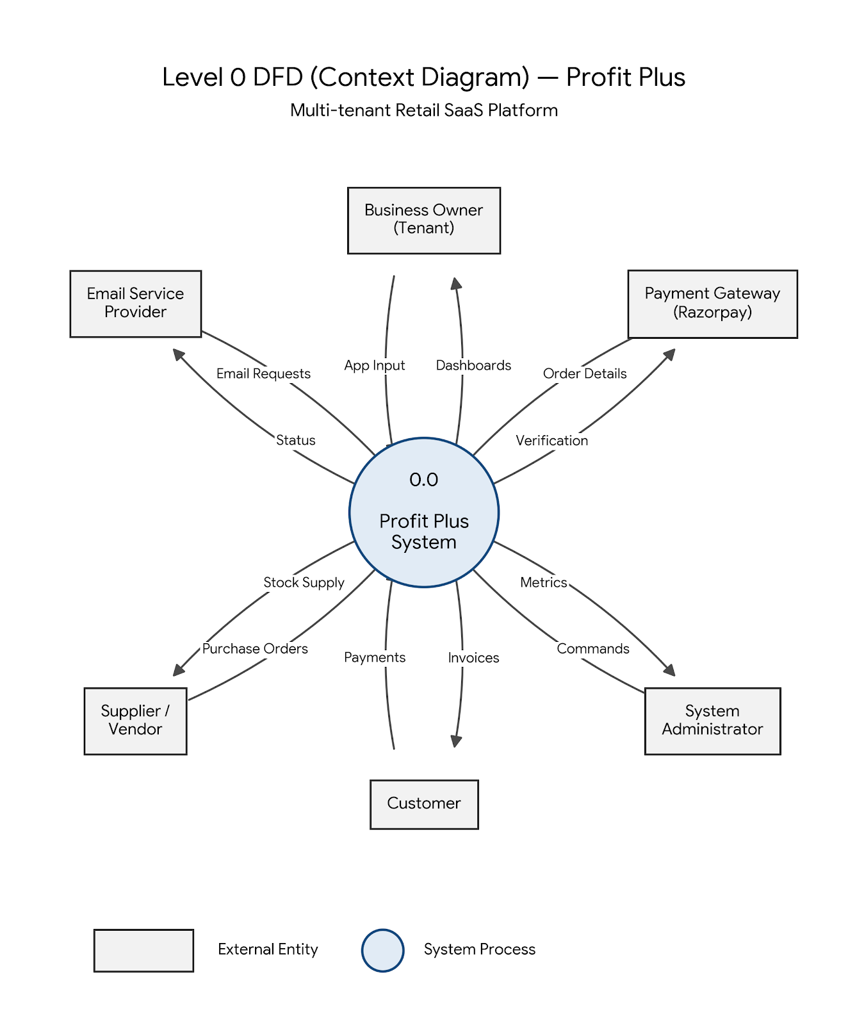
Explain:
In this diagram, the entire software is represented by a single circle in the center (labeled 0.0 Profit Plus System). Surrounding it are the External Entities—the people or third-party services that send data into the system or receive data back from it.
Here is how each entity interacts with Profit Plus:
- Business Owner (Tenant): This is the primary user. They send "App Input" into the system (like adding products, scanning barcodes, or processing bills) and in return, the system gives them "Dashboards" containing their inventory alerts, sales reports, and business insights.
- Customer: The end buyer. They provide "Payments" (like EMI installments or cash for bills) to the system, and the system automatically sends them their "Invoices" via PDF or email.
- Supplier / Vendor: The entity that provides stock. The system generates "Purchase Orders" for them when stock is low, and they provide the "Stock Supply" details back into the system.
- System Administrator: The super admin overseeing the SaaS platform. They send "Commands" (like locking a user account or updating the global subscription price) and receive global "Metrics" (like total revenue and active users) to monitor the platform's health.
- Email Service Provider: A third-party service used for communication. The system sends "Email Requests" (like an OTP for login or an invoice), and the service sends back the "Status" of whether the email was successfully delivered.
- Payment Gateway (Razorpay): The external service that handles subscription upgrades. Profit Plus sends "Order Details" to Razorpay, and Razorpay sends back the payment "Verification" so the system knows to upgrade the user to a PRO account.

2.2.3 Level 1 DFD
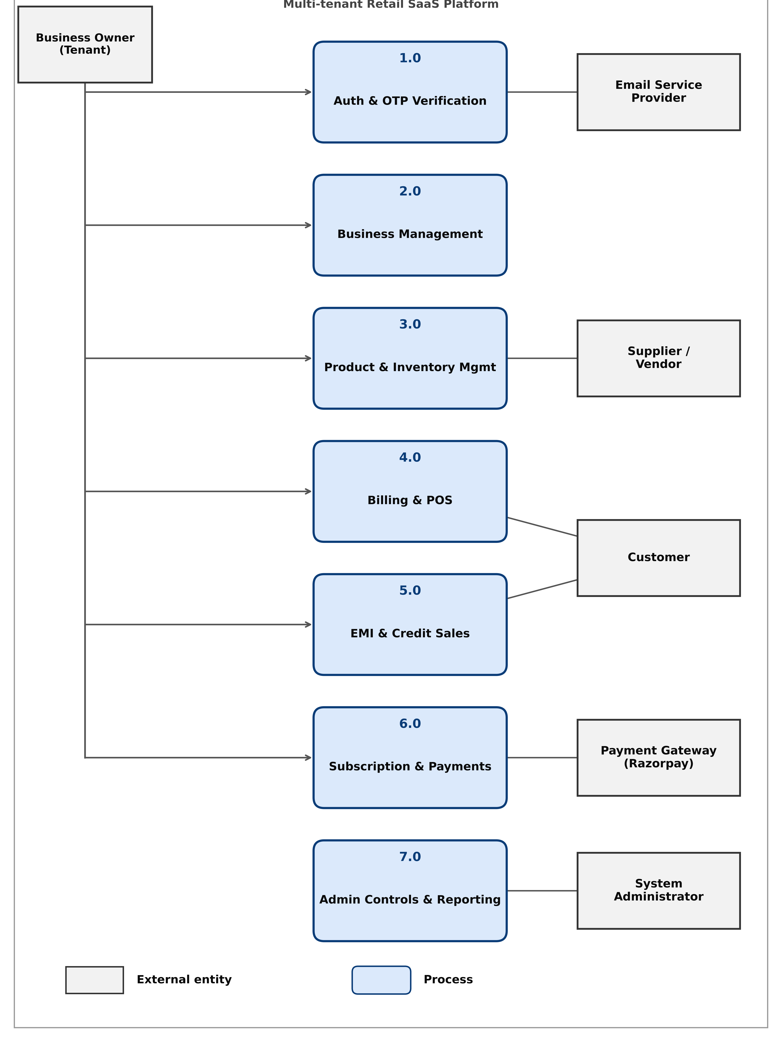

Explain:
The Business Owner (the shop/tenant using the app) is the main actor. That single vertical line running down the left side, with short arrows branching off into six of the seven processes, means: the Business Owner is the one triggering almost everything — signing up, managing their business profile, adding stock, billing customers, running EMI sales, and upgrading their subscription. Only process 7.0 (Admin Controls) doesn't involve them directly — that's not their job.
The middle column — the 7 processes
Each blue rounded box is a self-contained job the system does:
- 1.0 Auth & OTP Verification — logging in, verifying identity
- 2.0 Business Management — creating/editing the business profile
- 3.0 Product & Inventory Mgmt — stock and catalog
- 4.0 Billing & POS — making sales/invoices
- 5.0 EMI & Credit Sales — installment-based sales
- 6.0 Subscription & Payments — upgrading to PRO
- 7.0 Admin Controls & Reporting — platform-level oversight
The right side — everyone else who touches the system
Each gray box is an outside party that only interacts with one specific process, not the whole system:
- Email Service Provider only talks to Auth (sending OTPs)
- Supplier/Vendor only talks to Inventory (restocking)
- Customer talks to both Billing and EMI (they're the one being charged/paying installments) — that's why two lines converge on that one box
- Payment Gateway (Razorpay) only talks to Subscription (processing the upgrade payment)
- System Administrator only talks to Admin Controls (they manage the platform, not day-to-day business operations)

2.2.4 System Architecture Diagram
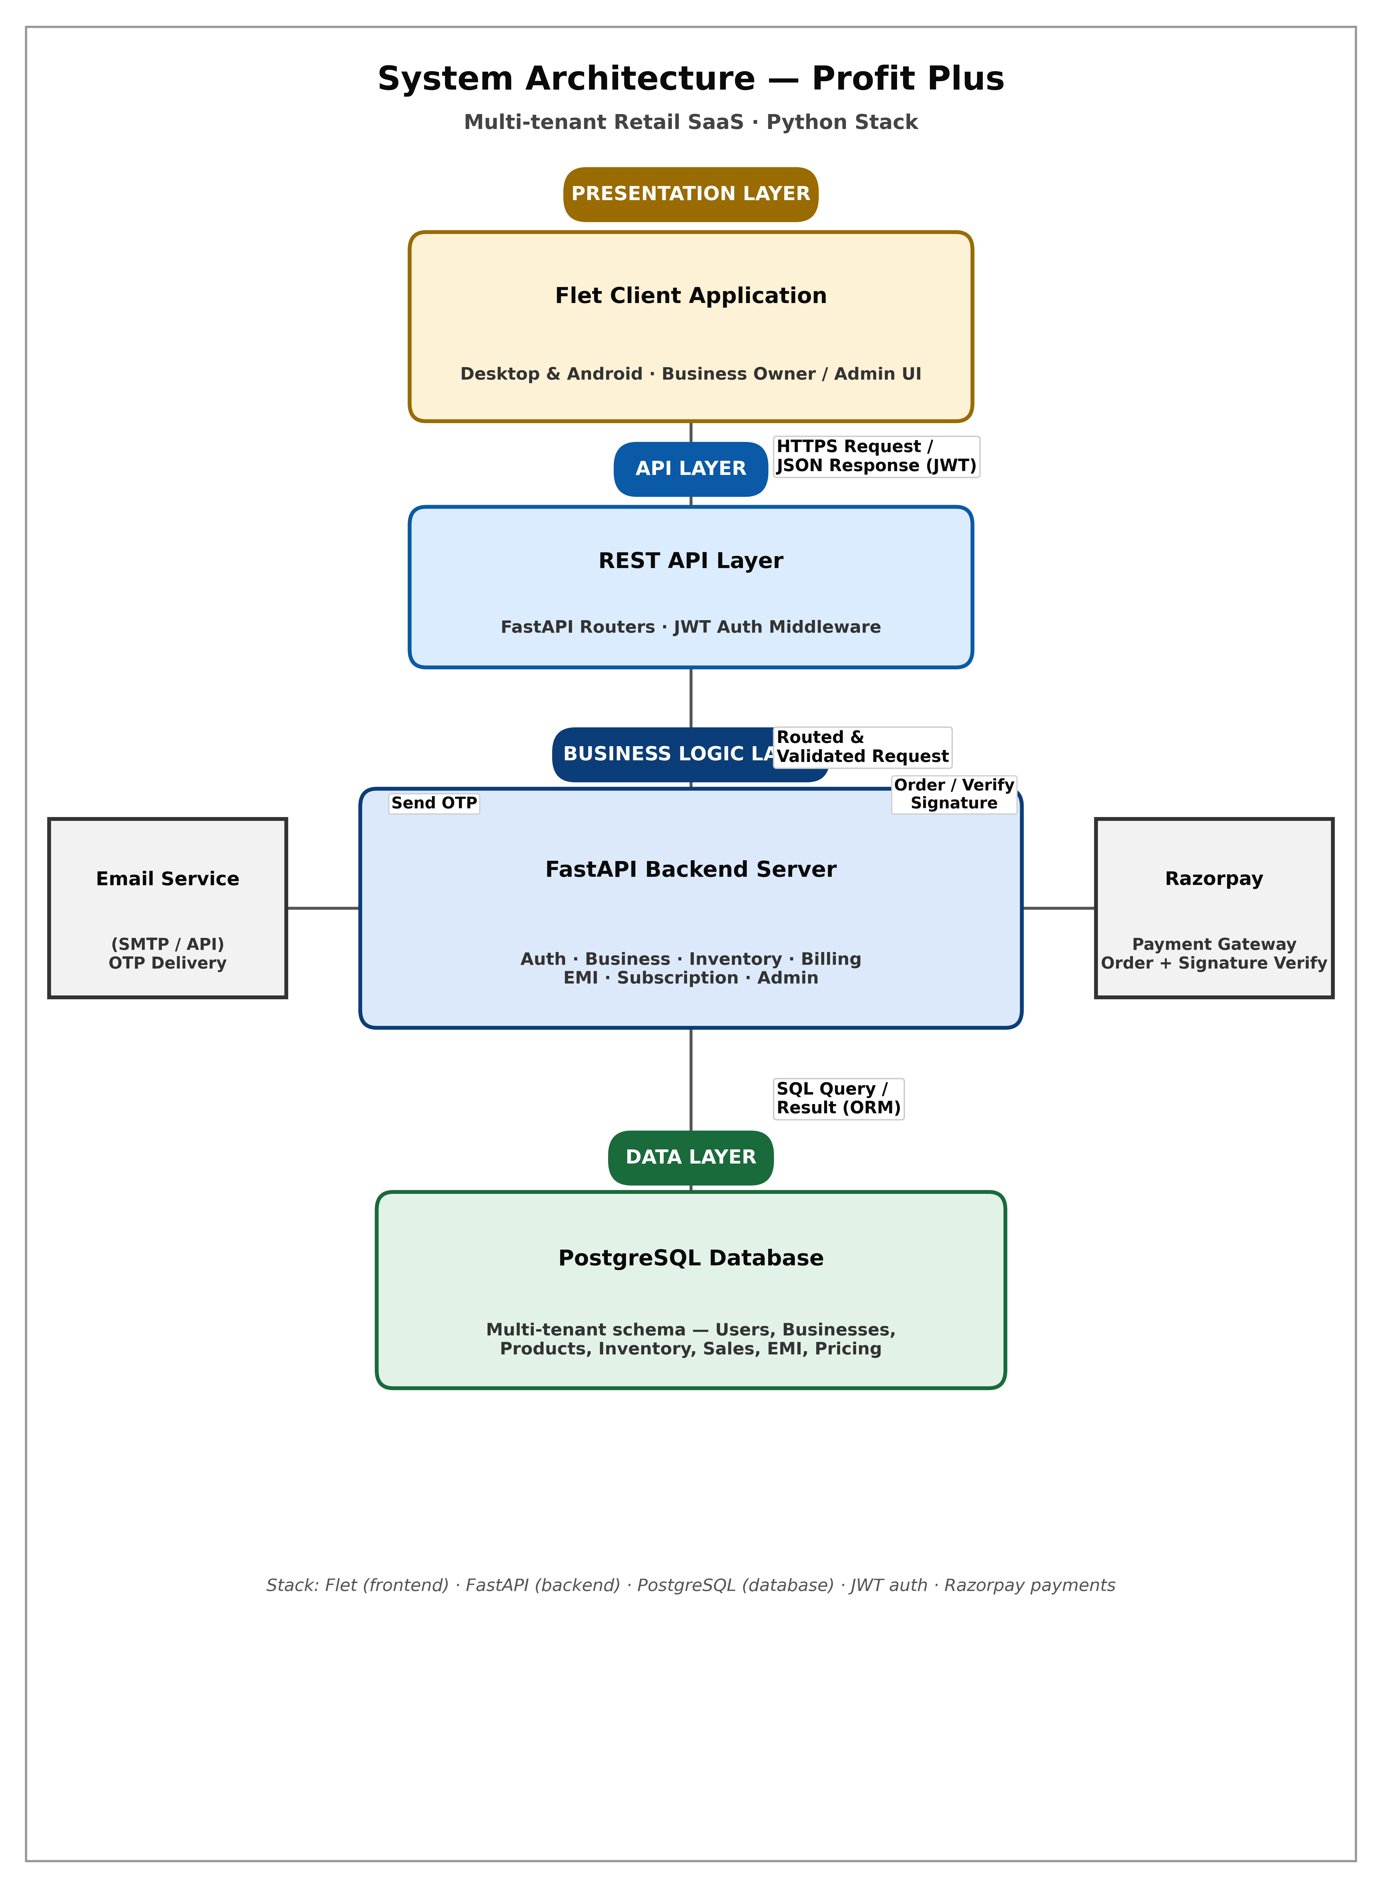
Explain
1. It starts on the user's screen.
Whether it's a shop owner opening the app on their laptop or their Android phone, they're looking at the Flet client — that's your UI layer. Say they hit "Create Bill" or "Add Stock."
2. The app fires off a request.
That tap turns into an HTTPS request carrying JSON data, plus the user's JWT token tucked in the header (proof they're logged in). This travels over the internet to your API layer.
3. FastAPI's router layer catches it first.
Before anything else happens, the JWT middleware checks the token — is this a real, still-valid session? If someone's account got locked by an admin, or the token's expired, it gets rejected right here with a 403, never even reaching your business logic.
4. Once validated, it's handed to the right module.
Your FastAPI backend isn't one giant blob — it's split into routers: Auth, Business Management, Inventory, Billing, EMI, Subscription, Admin. The request gets routed to whichever one owns that job. A billing request goes to the Billing module; an OTP request goes to Auth.
5. Sometimes the backend needs to talk to the outside world.
- If it's a signup, Auth reaches out sideways to the Email Service to fire off an OTP.
- If it's a PRO upgrade, the Subscription module reaches out to Razorpay — creates an order, later verifies the payment signature Razorpay sends back.
These are side-conversations — the backend pauses, waits for that external service to respond, then continues.

6. The actual data lives in PostgreSQL.
For almost everything — checking stock, saving a sale, logging an EMI payment — the backend talks down to the database using SQLAlchemy (the ORM). It's multi-tenant, so every query is automatically scoped to that business owner's data only — one shop never sees another's numbers.
7. The response climbs back up the same way.
Database → backend logic finishes processing → API layer packages it as JSON → travels back over HTTPS → lands back on the user's screen, maybe as a printed invoice or an updated stock count.

2.3 Database Design:
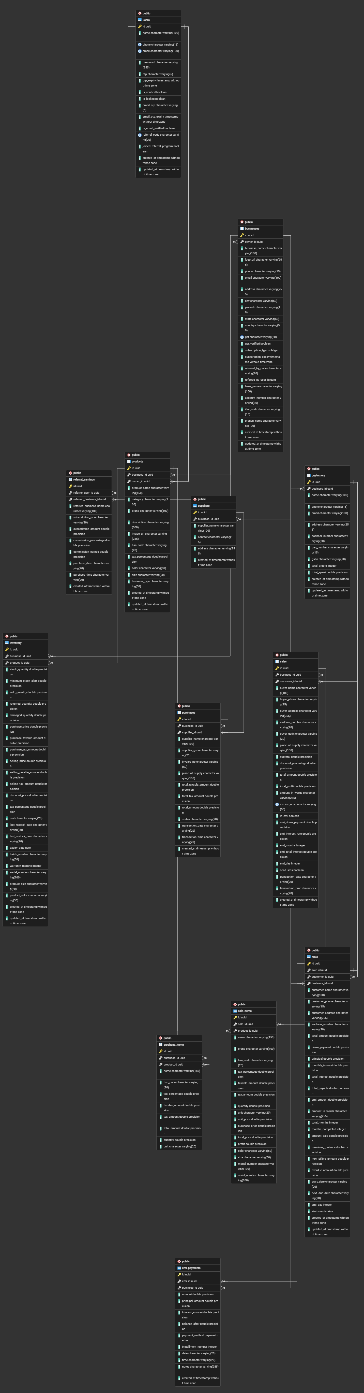
Explain:
The ER diagram for Profit Plus maps out the relationships between the different data modules required to run a multi-tenant SaaS platform. Because the application handles everything from user authentication to inventory and billing, the database is logically grouped into several interconnected areas:
1. Identity and Business Management
At the top of the hierarchy are the tables that manage access and core profiles.
- Users Table: This table acts as the entry point, storing user credentials, lock statuses (is_locked), roles (like admin or owner), and OTP hashes for secure logins.
- Businesses Table: Linked directly to the Users table, this stores individual business profiles, GST details, logos, and their current subscription tier (FREE or PRO). This connection is what enables the multi-tenant architecture, allowing one user to own multiple distinct businesses.
- Pricing Config Table: A separate configuration module that stores dynamic subscription pricing managed by the Super Admin.
2. Product and Inventory Tracking
The core operational tables handle what a business actually sells.
- Products Table: This acts as the master catalog, storing universal item details like categories, brands, colors, sizes, and HSN codes.
- Inventory Table: This is heavily linked to the Products table. It tracks the real-time physical stock quantities, barcodes, purchase prices, selling prices, and generates low-stock alerts.

3. Sales and Customer Relations
When a transaction occurs, data flows into these relational tables.
- Customers Table: Stores contact details, purchase histories, and outstanding dues for the end-consumers.
- Sales Table: This table records the actual transactions, linking the sold items from the Inventory table to the specific Customer. It logs subtotals, taxes, transaction modes, and stores the generated invoice PDFs.
- EMI Table: For credit sales, this table links to the Sales and Customers tables to store credit agreements, installment schedules, and logs of partial payments.
4. Supply Chain Management
Finally, the system tracks incoming stock to complete the business lifecycle.
- Suppliers Table: Stores the contact and vendor details for the entities supplying the goods.
- Purchases Table: Linked to the Suppliers and Inventory tables, this logs vendor purchase orders and the history of stock replenishment.
The connecting lines in the diagram represent strict data isolation and dependency. For example, a "Sale" cannot exist without linking back to a specific "Business," "Customer," and "Product." This interconnected design ensures that when a product is sold at the POS, the inventory automatically updates, the customer's purchase history is logged, and the business's overall revenue metrics are correctly calculated.

2.3.1 Tables:
T1 - Users  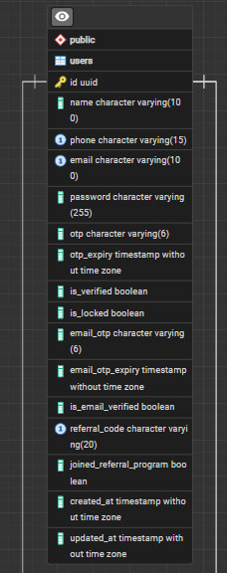 | T2 - Businesses  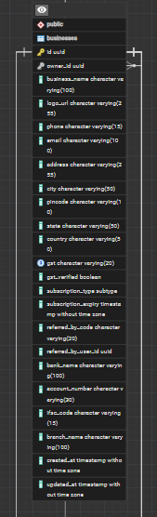

T3 – Products  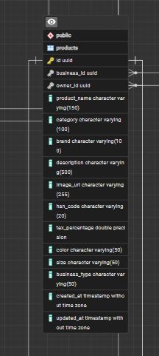 | T4 – Inventory  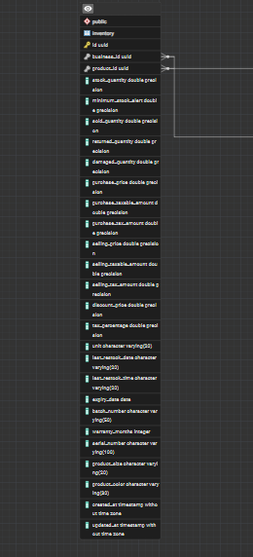

T5 – Customer  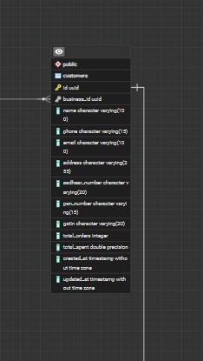 | T6 – Supplier  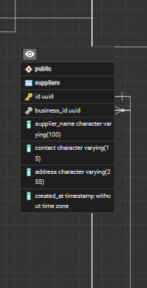

T7 – Sales  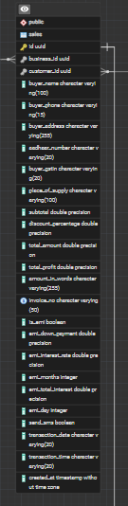 | T8 – Purchase  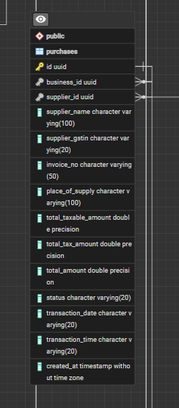

T9 – EMI and Payments  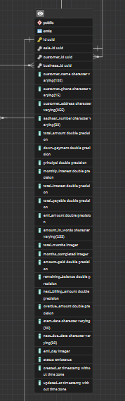 | Extra DTOs – Sales and Purchase  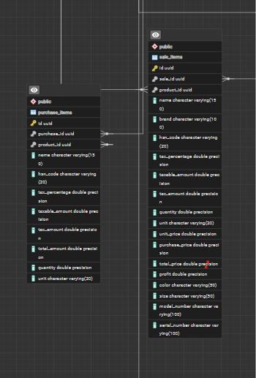

2.4 Project Screenshots:

2.4.1 Signup and Login:
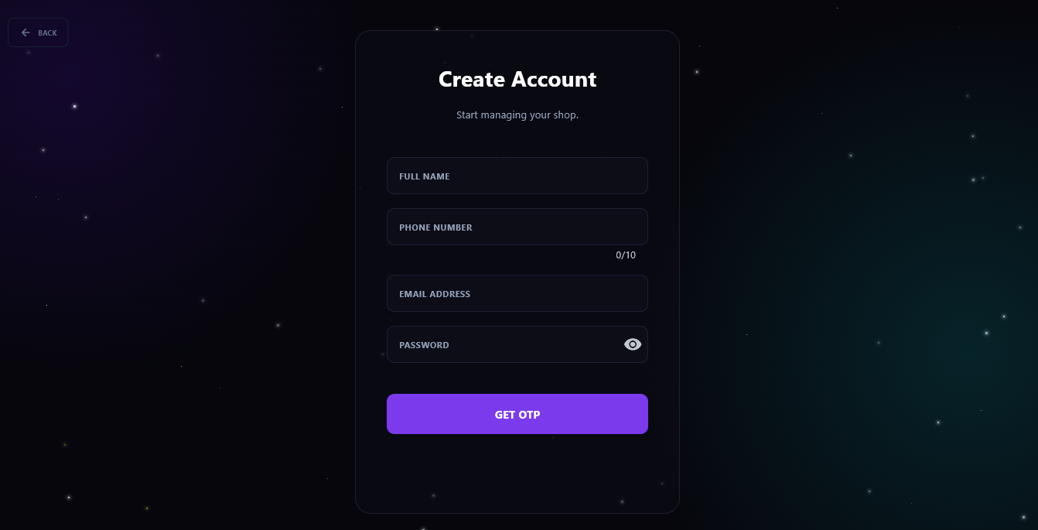
Explain:
Data Collection Fields: The form captures essential user details required to set up the initial profile in the Users database table. The input fields include:
- Full Name: For personalizing the user experience.
- Phone Number: Includes a built-in character counter (0/10) to enforce standard 10-digit mobile number validation.
- Email Address: Used as the primary communication channel and unique identifier for login.
- Password: Features a visibility toggle (the "eye" icon) allowing users to securely verify their password before submitting.
OTP-Based Verification Flow: Instead of standard immediate account creation, the primary Call-to-Action (CTA) button is labeled "GET OTP". This highlights the platform's focus on security. Upon clicking, the system initiates Process 1.0 (Auth & OTP Verification), sending a One-Time Password to the provided email to verify the user's identity before officially generating the account.

2.4.2 Log-in
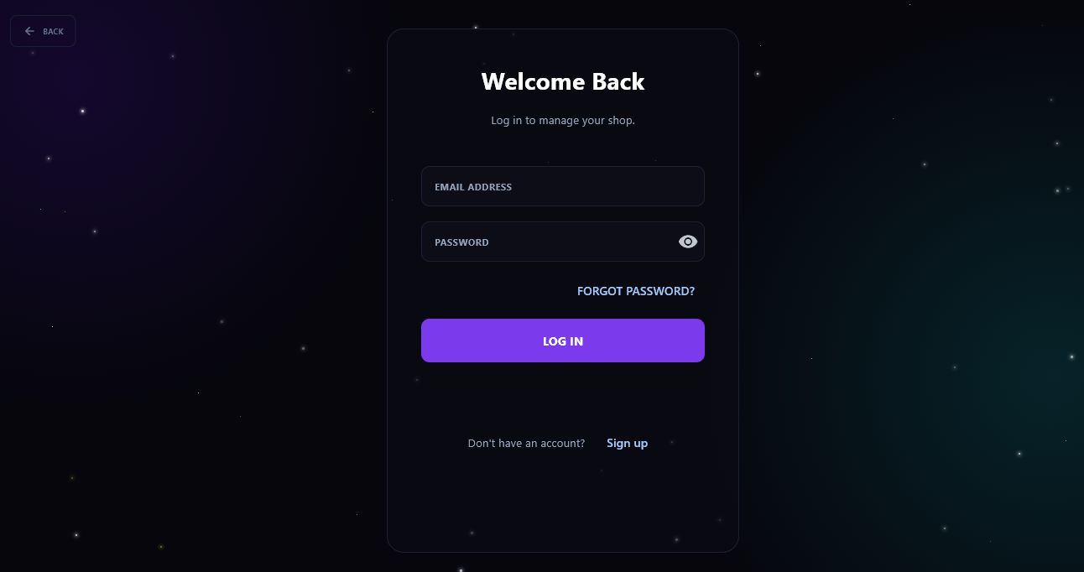
Explain:
This image displays the Login Screen, which serves as the primary security gateway for Business Owners to access their tenant workspace.
Core Function: Authenticates returning users and grants them access to their isolated business data.
Data Capture: Requires the user's registered Email Address (acting as the unique primary identifier) and Password (features a visibility toggle for input accuracy).
Backend Verification (Process 1.0): Upon clicking "LOG IN", the application queries the Users Table. It validates the credentials (using BCrypt password encryption) and evaluates the is_locked status to ensure the Super Admin has not suspended the account.
Session Authorization: Upon successful validation, the system generates and issues a secure JWT (JSON Web Token), which maintains the user's session and scopes their access strictly to their own business data.

2.4.3 Forgot password
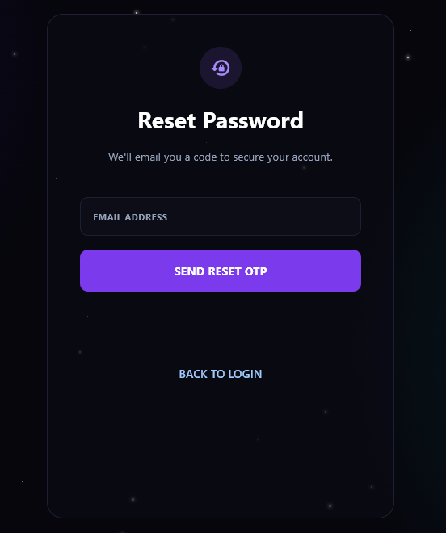
Alternative Workflows:
- Forgot Password: Triggers a password recovery process that communicates with the Email Service Provider to dispatch a secure reset OTP.
- Sign Up: Routes unauthorized users to the tenant registration module to create a new record in the Users database.

2.4.4 Create Businesses
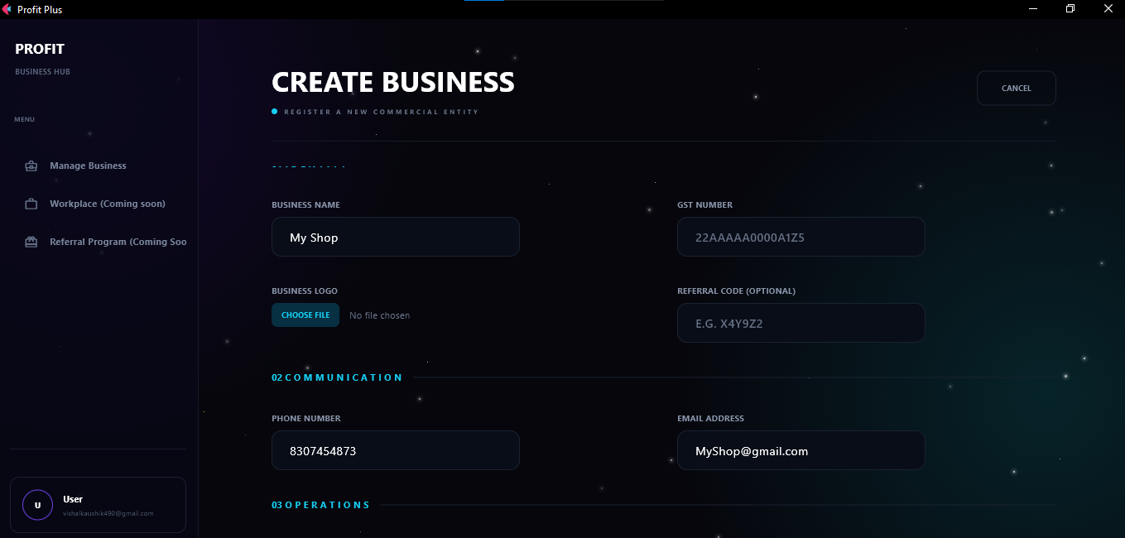
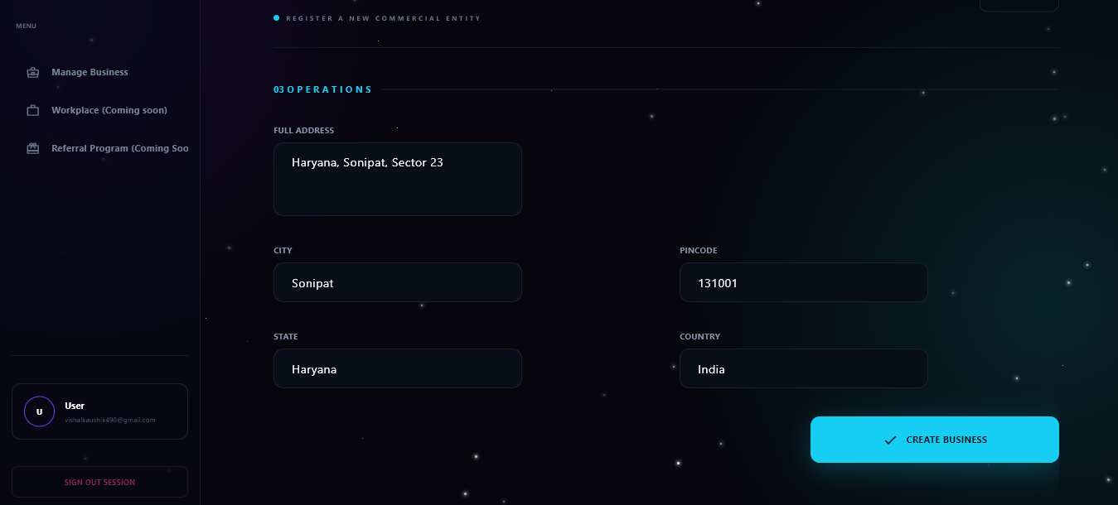
Explain:

Setting Up a New Shop (Create Business)
These two screenshots show the Create Business form. This is where a user actually sets up their digital store inside the app.
The Main Goal: This screen allows a logged-in user to register their shop so they can start managing inventory and billing.
What Information is Collected: The form is broken down into three easy sections:
  - Commercial Details: It asks for the basics like the shop's name, their GST number for taxes, and lets them upload a store logo. This logo will eventually show up on the printed receipts!
  - Communication: It collects a public phone number and email specifically for the shop, so customers have a way to reach them.
  - Operations (Location): It takes down their full physical address. The app is smart and will later pull this exact address to automatically fill out the invoices when they make a sale.
What Happens Behind the Scenes: When the user clicks that blue "CREATE BUSINESS" button at the bottom, the app saves all this info into the database. It instantly links this new shop directly to the user who is currently logged in (you can see their profile in the bottom left corner). This makes sure their shop's data is completely private and kept separate from anyone else using the app.

2.4.5 My Businesses
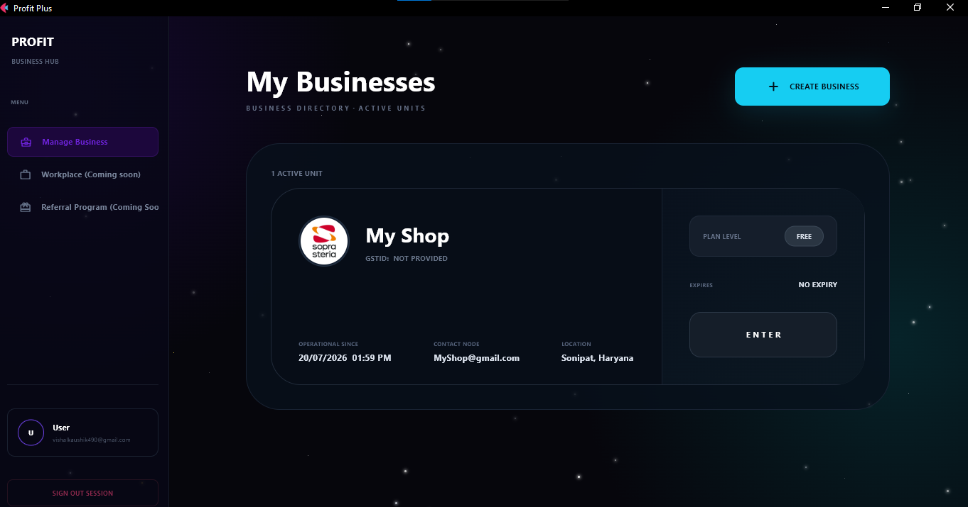

2.4.6 Add Products
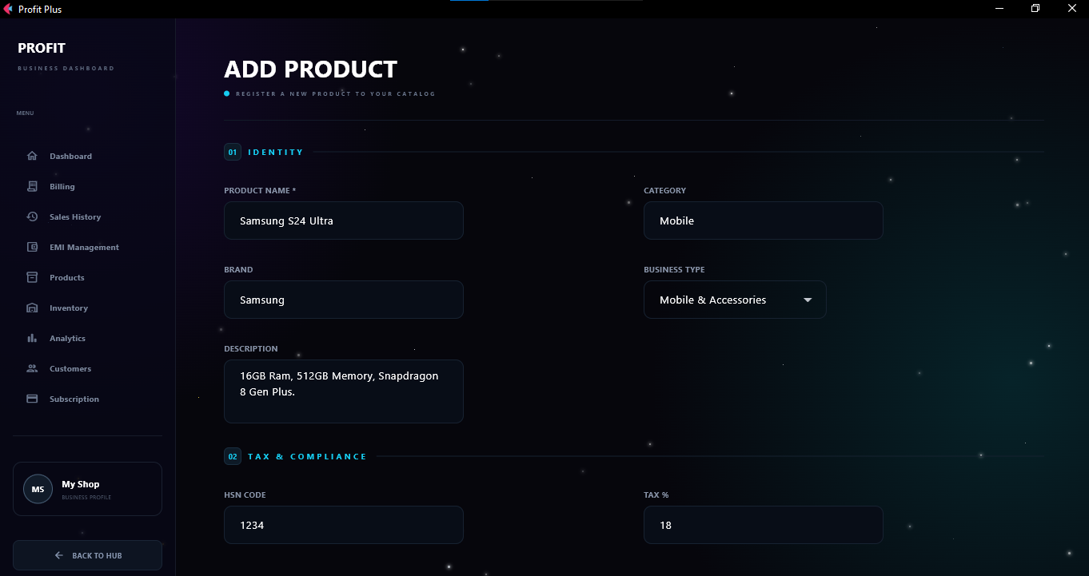
Explain:
This screenshot shows the Add Product screen. This is exactly where a shop owner goes to add a brand-new item they want to sell into their system.
- The Main Menu (Sidebar): On the left side, you can see the main menu for the shop owner. It gives them quick access to all their daily tools like Billing, Inventory, and Customers. Down at the bottom left, it clearly displays which store ("My Shop") they are currently working inside.
- Section 01: Identity: This top section is all about describing the item. The owner types in the product's name (like a "Samsung S24 Ultra"), sorts it by category and brand, and types out a quick description. This keeps their digital catalog super organized and easy to search.
- Section 02: Tax & Compliance: This bottom part handles the billing rules. The owner enters the HSN code (a standard code used for tax purposes) and the tax percentage (like 18%).
- Behind the Scenes: Once saved, this information goes into the main Products database. From there, the owner can go to the "Inventory" section to actually add how many boxes of this phone they have in stock.

2.4.7 My Products
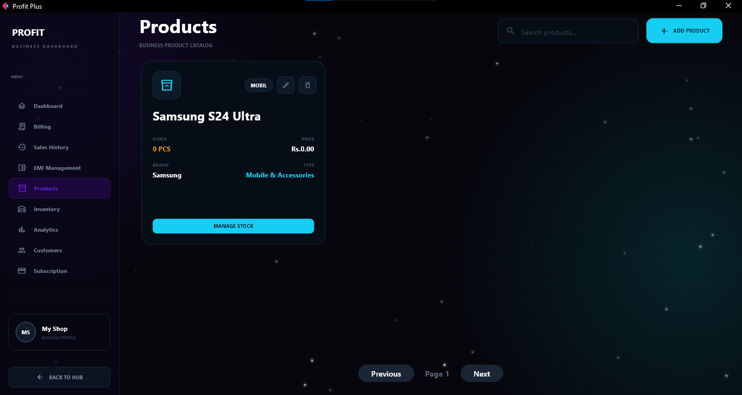
It shows the saved products with delete and edit functionality.

2.4.8 Manage Stocks
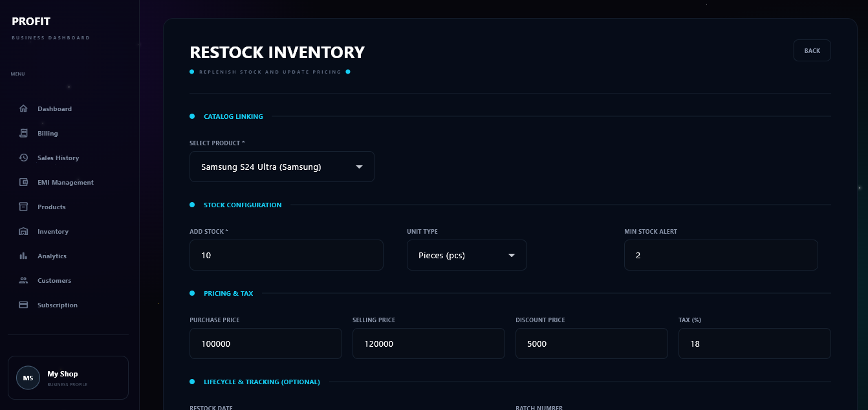
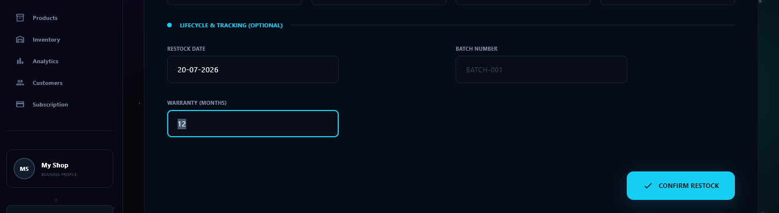
Explain:

Restocking and Managing Inventory
These screenshots show the Restock Inventory screen. After a product (like the Samsung phone from the previous step) is added to the catalog, this is where the shop owner actually puts it on their digital shelves.
- Catalog Linking: Instead of retyping everything, the owner just selects the product they already created from a simple drop-down menu.
- Stock Configuration: This is where they tell the system how many items they are putting in the store. In this example, they are adding 10 pieces. They also set a "Min Stock Alert" to 2. This is a really helpful feature that will automatically warn the owner when they are almost sold out, so they know it's time to order more from their supplier.
- Pricing & Tax: The owner enters what they paid for the item (Purchase Price) and what they want the customer to pay (Selling Price), along with any discounts. Because the system knows both the buying and selling price, it can automatically calculate the shop's total profit later on!
- Lifecycle & Tracking: In the bottom section, they can record the exact date the stock arrived, assign a batch number, and even log that the phone comes with a 12-month warranty.

2.4.9 Inventory
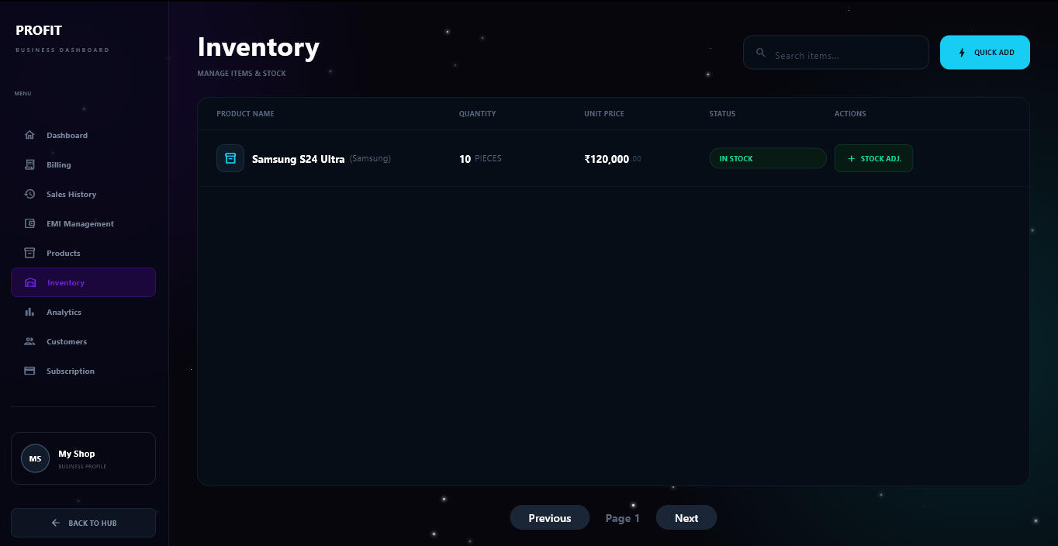
All the added stock will be shown here

2.4.10 Billing
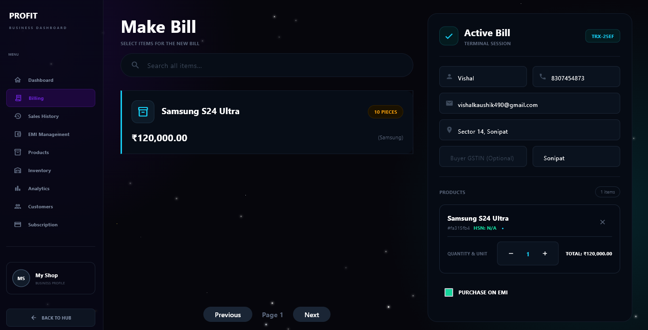
Explain:

Creating a Sale (The Billing Counter)
This screenshot shows the Make Bill screen, which acts as the digital cash register for the shop. This is where all the setup from the previous steps finally comes together to make a sale!
- Finding the Product (Middle Section): The shop owner can use the search bar to find an item or just click on it from the list. Notice the "Samsung S24 Ultra" card? It clearly shows the price (₹120,000) and displays a yellow badge saying "10 PIECES". This shows that the system is pulling live data directly from the inventory we just restocked!
- Customer Details (Right Panel): The right side of the screen is the active shopping cart. The top half allows the owner to quickly type in the buyer's information, like their name, phone number, email, and address. Saving this info helps the business build a customer database for future support or marketing.
- The Cart & EMI Option (Bottom Right): Below the customer info, you can see the phone sitting in the cart. The owner can easily click the plus or minus buttons to change the quantity. There is also a very handy "PURCHASE ON EMI" checkbox at the very bottom. If the customer wants to pay in monthly installments instead of all at once, the owner just checks this box, and the system will automatically set up a credit plan!

2.4.11 Sale Confirmed
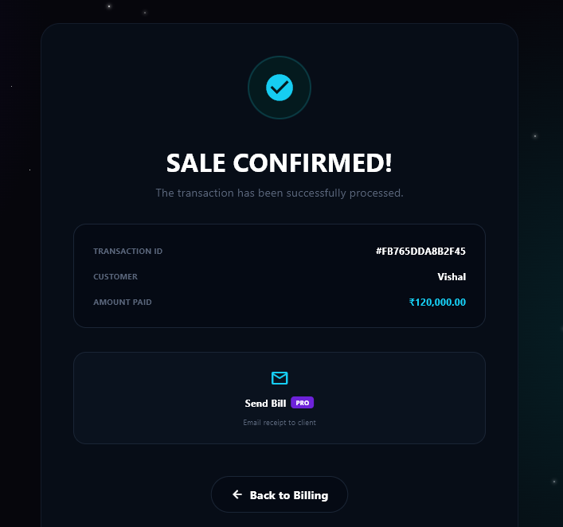

2.4.12 Subscription
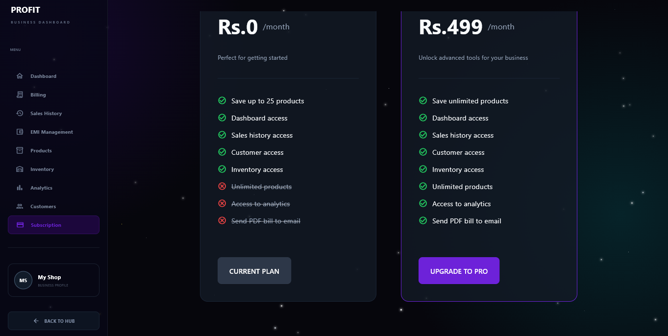

Explain
This screenshot shows the Subscription page. Since Profit Plus is a Software-as-a-Service (SaaS) platform, this is where the shop owner can manage their billing plan and unlock premium features for their business.
Here is a simple breakdown of how this page works:
- The Free Plan (Rs. 0/month): On the left, you can see the shop is currently on the free starter plan (marked as "CURRENT PLAN"). This is great for new businesses just testing the waters. It gives them full access to the dashboard, billing, and inventory, but strictly limits their catalog to a maximum of 25 products. You can clearly see the premium features they are missing crossed out with red marks at the bottom.
- The Pro Plan (Rs. 499/month): On the right is the premium tier. If the business is growing and needs more power, they can upgrade to this plan. It removes the product limit (allowing unlimited items in their catalog) and unlocks advanced tools like the Analytics dashboard and the ability to automatically email PDF receipts to their customers.
- Behind the Scenes: When the owner clicks that purple "UPGRADE TO PRO" button, the application temporarily hands them over to a secure external payment gateway (like Razorpay). Once the Rs. 499 payment is successful, the app's database instantly updates this specific shop's status to "PRO," immediately unblocking access to the analytics and email features across their entire dashboard!

2.4.13 Payment Gateway
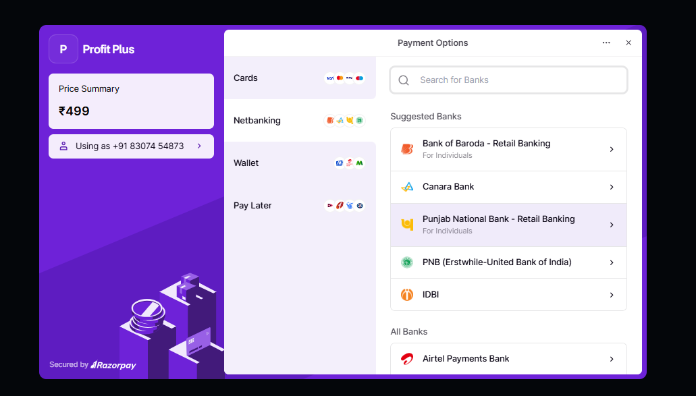
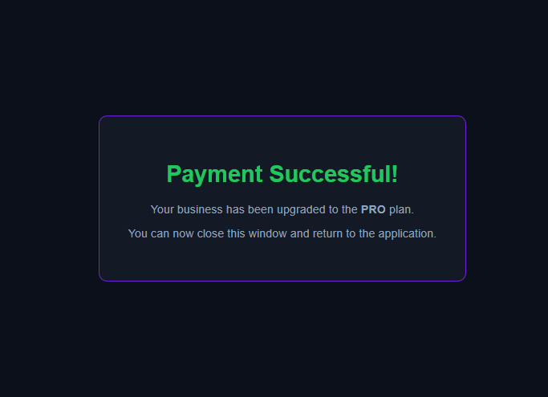

2.4.14 Emi Management
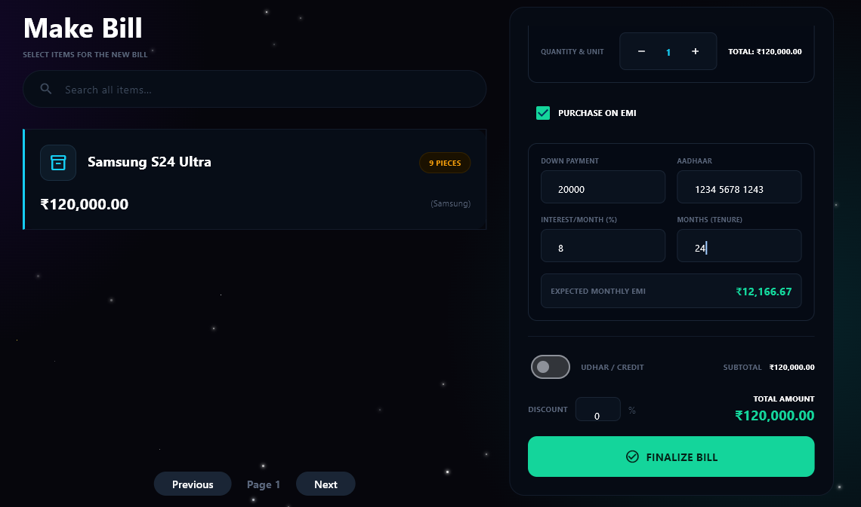
Explain:

Selling on EMI (Installment Payments)
This screenshot shows exactly what happens when the shop owner checks the "PURCHASE ON EMI" box at the billing counter. It opens up a built-in calculator for customers who want to buy an expensive item but pay for it in monthly installments.
- Live Inventory Updates: If you look closely at the Samsung phone on the left, the yellow badge now says "9 PIECES". This shows that the system's inventory is updating in real-time, having already subtracted the phone we "sold" in the previous step!
- The EMI Form: Once the EMI box is ticked, a new section appears on the right. The shop owner simply types in the upfront Down Payment (₹20,000) and links the customer's Aadhaar number for security and identity tracking.
- Automatic Math: The owner then enters the interest rate (8%) and how many months the customer will take to pay (24 months). The app instantly calculates the exact Expected Monthly EMI (₹12,166.67) right there in green text. The owner doesn't have to use a calculator at all.

2.4.15 Generated Bill on Mail
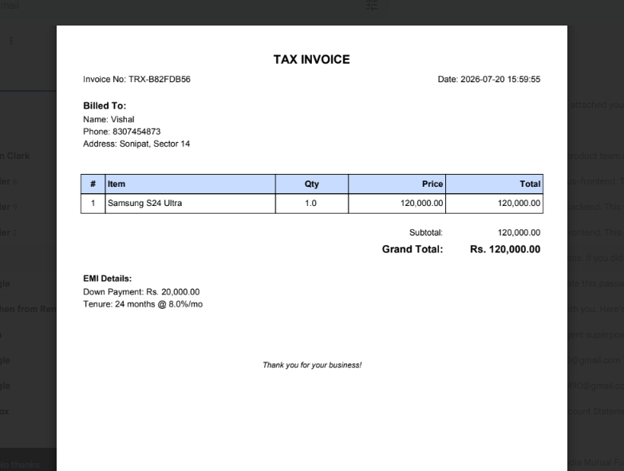

2.4.16 Sales History
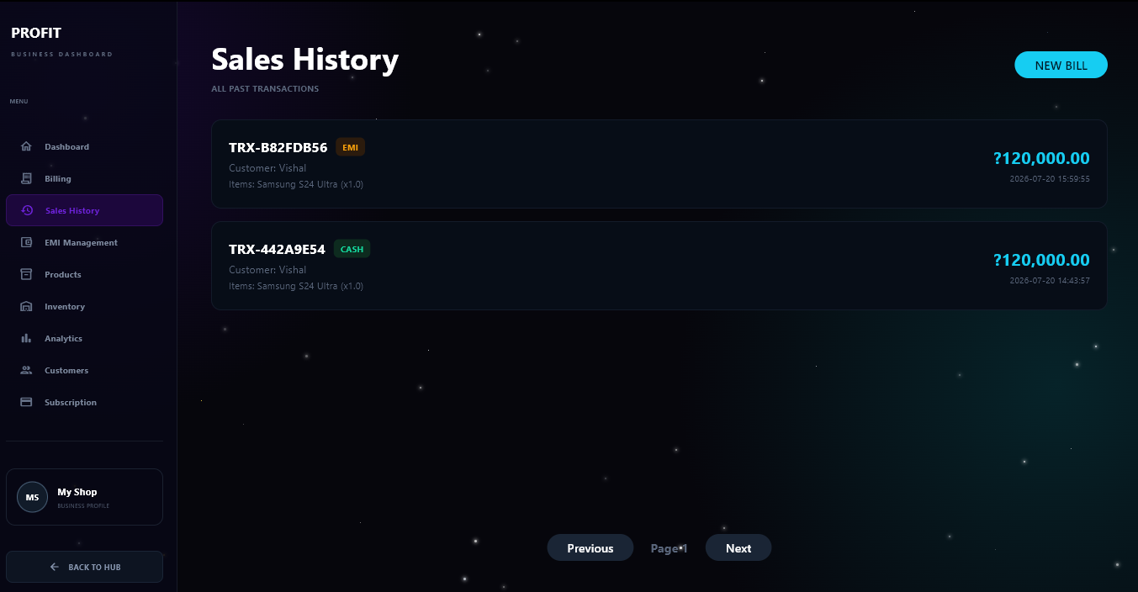

2.4.17 Customer Records
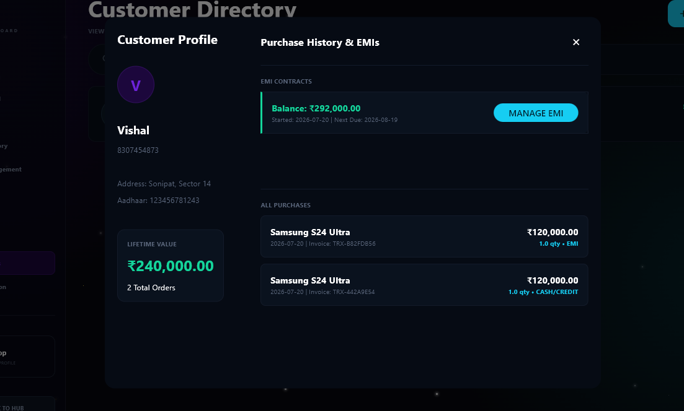
Explain:

Viewing Customer Profiles and History
This screenshot displays the Customer Profile screen. Whenever a shop owner needs to look up a specific buyer or check their payment history, this is the dashboard they use.
- Customer Identity (Left Panel): The left side pulls up all the personal details saved during checkout, such as their name, phone number, and address (like Sector 14, Sonipat). Below that is a great business feature: the Lifetime Value tracker. It automatically calculates exactly how much money this specific person has spent at the store over time (₹240,000 across 2 orders).
- Active EMI Contracts (Top Right): If the customer has an ongoing installment plan (like the one we set up in the previous step), it sits right at the top. The owner can instantly see the remaining balance, the day the contract started (July 20, 2026), and when the next payment is due. Clicking the blue "MANAGE EMI" button allows the shop owner to easily log a customer's monthly payment when they come into the store.
- Purchase History (Bottom Right): This section acts as a digital receipt book just for this customer. It lists every single item they have ever purchased, the exact date, the invoice number, and the payment method. For example, you can see this customer bought one Samsung phone on EMI and another using Cash/Credit.

2.4.18 Analytics Section:
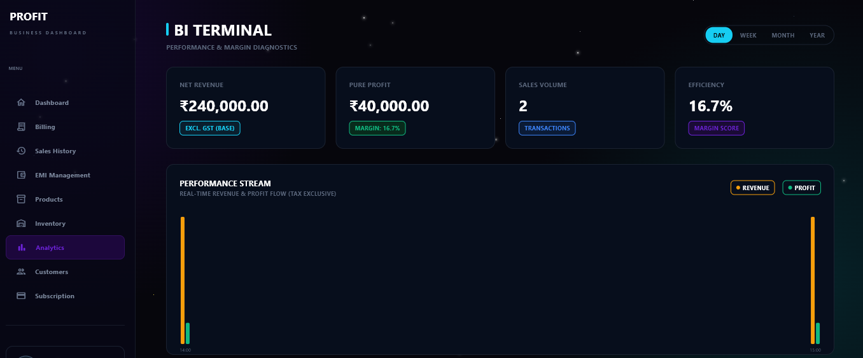
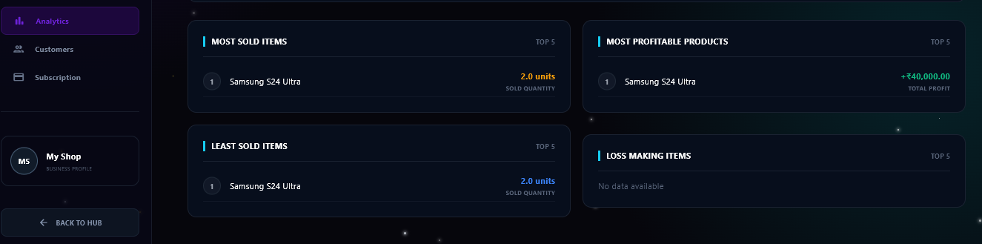

Explain

Business Intelligence & Analytics Terminal
These two screenshots show the Analytics Dashboard (labeled as the BI Terminal). Once a shop owner upgrades to the Pro plan, this page unlocks to give them deep, real-time insights into how their business is actually performing.
Core Performance Metrics (Top Cards): The dashboard calculates four essential metrics to give the owner a snapshot of their shop's financial health:
  - Net Revenue: Displays total sales incoming cash excluding taxes (showing ₹240,000.00 from the two phones sold earlier).
  - Pure Profit: Calculates the actual money made after subtracting the original buying cost from the selling price (showing ₹40,000.00).
  - Sales Volume: Displays the total number of transactions processed (2 transactions).
  - Efficiency Score: Shows the total profit margin percentage (16.7%).
Performance Stream Graph: Below the cards, a visual chart maps out real-time revenue and profit flow side-by-side using high-contrast colored bars. This helps the owner see exactly what hours or days of the week bring in the most money. Time filters at the top right allow the admin to switch views between Day, Week, Month, and Year.
Top 5 Performance Rankings (Bottom Section): The system automatically groups inventory items into diagnostic categories so the owner can make smart business decisions:
- Most Sold vs. Least Sold Items: Tracks physical quantities out the door (showing 2.0 units of the Samsung S24 Ultra).
- Most Profitable Products: Highlights exactly which items generate the highest total profit margins (showing a +₹40,000.00 return on the phones).
- Loss Making Items: An early warning system that catches items selling under cost or gathering dust (currently showing "No data available," which means the shop is operating cleanly!).

2.4.19 Shop Dashboard
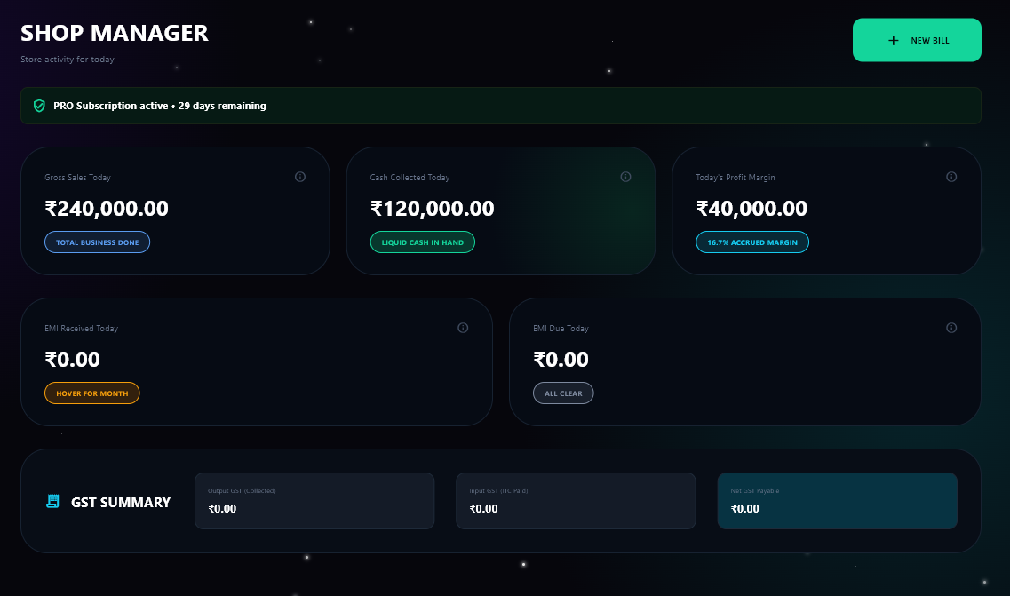
Explain:

Shop Manager (Business Dashboard)
This screenshot shows the main Shop Manager Dashboard, which acts as the primary command center for the store owner. It gives a quick glance at the current day's business activity, cash flow, subscription standing, and tax compliance status.
Quick Action & Subscription Banner:
- At the top right, a prominent "+ NEW BILL" button acts as a direct shortcut to launch the billing counter interface.
- A status bar at the top confirms that the store has a "PRO Subscription active" with "29 days remaining", indicating a successful upgrade and tracking the active billing lifecycle.
Daily Financial Trackers (Top Metric Cards): Three core counters track live operational performance for the current business day:
- Gross Sales Today: Displays the total billing invoice amount generated (₹240,000.00).
- Cash Collected Today: Tracks the physical or immediate liquid currency received on the spot (₹120,000.00), automatically accounting for split finances like immediate down payments vs. credit loans.
- Today's Profit Margin: Displays the direct earnings calculated from the markup between inventory purchase cost and sale price (₹40,000.00, reflecting a 16.7% accrued margin).
Credit and Installment Trackers (Middle Metric Cards): Two dedicated spaces help owners keep tabs on outstanding customer tabs:
- EMI Received Today: Monitors how much money was collected from customers paying off existing monthly dues.
- EMI Due Today: A critical warning card showing if any active customer accounts are scheduled to make an installment payment today (currently reading ₹0.00 or "ALL CLEAR").
GST Summary (Bottom Panel): A automated ledger at the base helps the store track its government tax liabilities:
- Output GST (Collected): The tax gathered from sales made to customers.
- Input GST (ITC Paid): The tax credit the business accumulated when buying stock from suppliers.
- Net GST Payable: The final amount the store needs to settle with tax authorities, calculated automatically by subtracting Input GST from Output GST.

Admin Side Flow:

2.4.20 Overview Stats
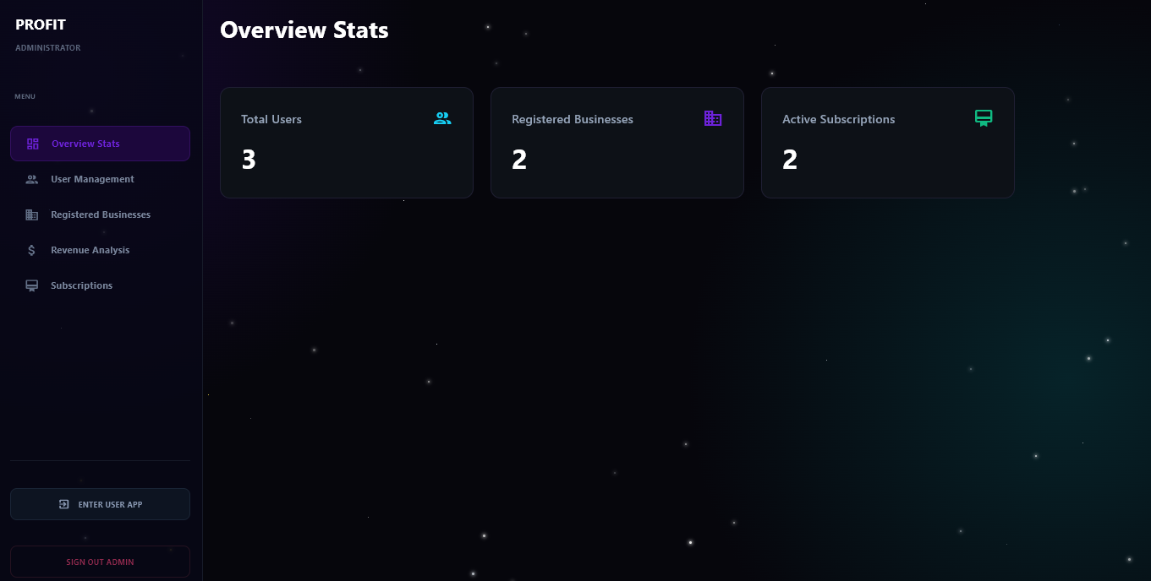
Explain:

Super Admin Dashboard (Platform Growth)
This screenshot brings us full circle back to the Super Administrator Dashboard. If you remember the very first screenshot we looked at, this is that exact same global control panel, but the numbers have officially gone up!
- The Big Picture: This is the "God-mode" view for the creator of the Profit Plus software. Instead of looking at just one store's sales, this screen tracks the health of the entire multi-tenant platform.
- Total Users (3): This shows that there are currently 3 individual accounts registered on the whole platform.
- Registered Businesses (2): This number jumped from 1 to 2! This proves that the multi-tenant architecture is working perfectly. Another user has successfully completed the "Create Business" flow and set up their own completely isolated digital shop.
- Active Subscriptions (2): This number also jumped from 1 to 2. It shows that the new business we just walked through successfully went through the payment gateway and upgraded to the premium PRO plan.

2.4.21 User Management
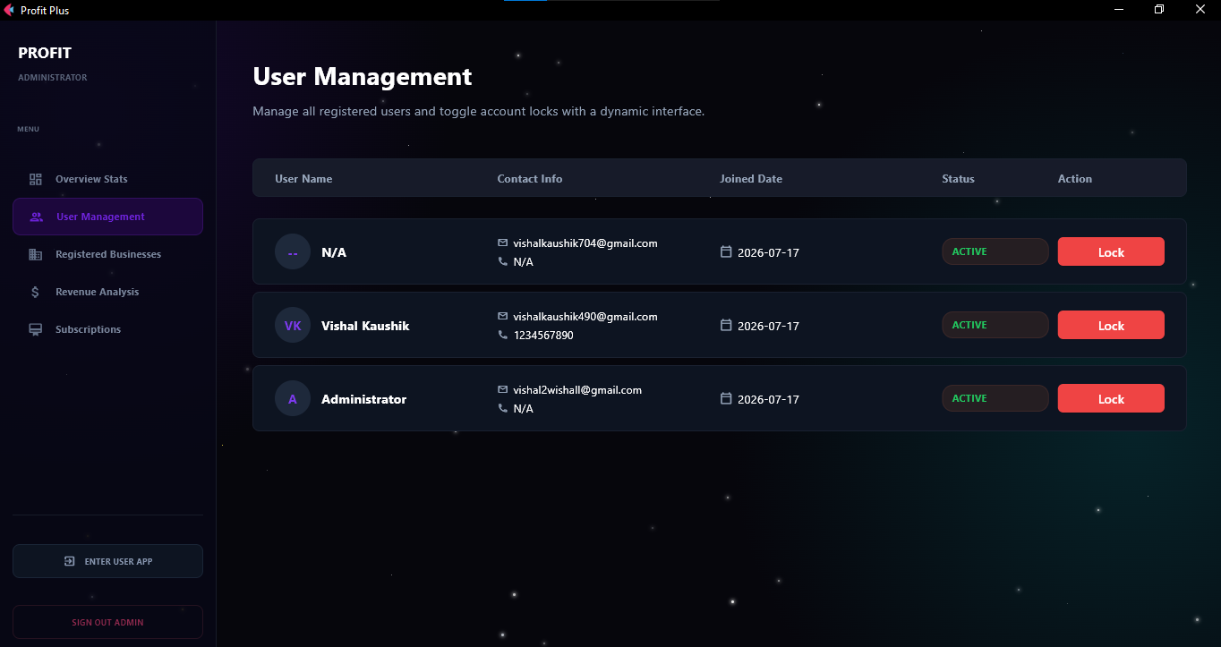

Managing Platform Users (Admin Controls)
This screenshot shows the User Management screen. Since we are back in the Super Administrator dashboard, this page is the main control center for overseeing everyone who has signed up for the Profit Plus software.
- The Master List: The screen displays a clear, organized list of every single person who has created an account on the platform. It automatically pulls up their name, email address, phone number, and the exact date they joined.
- Live Status Monitoring: Next to each user, there is a green badge that says "ACTIVE." This lets the platform owner know at a glance that these users are in good standing and can currently log into their shops.
- The "Lock" Feature: The most important tool on this page is the bright red "Lock" button on the far right. This acts as an emergency brake. If a user stops paying for their subscription, violates the terms of service, or has a security issue, the admin can click this button to instantly suspend their account.

2.4.22 Registered Businesses
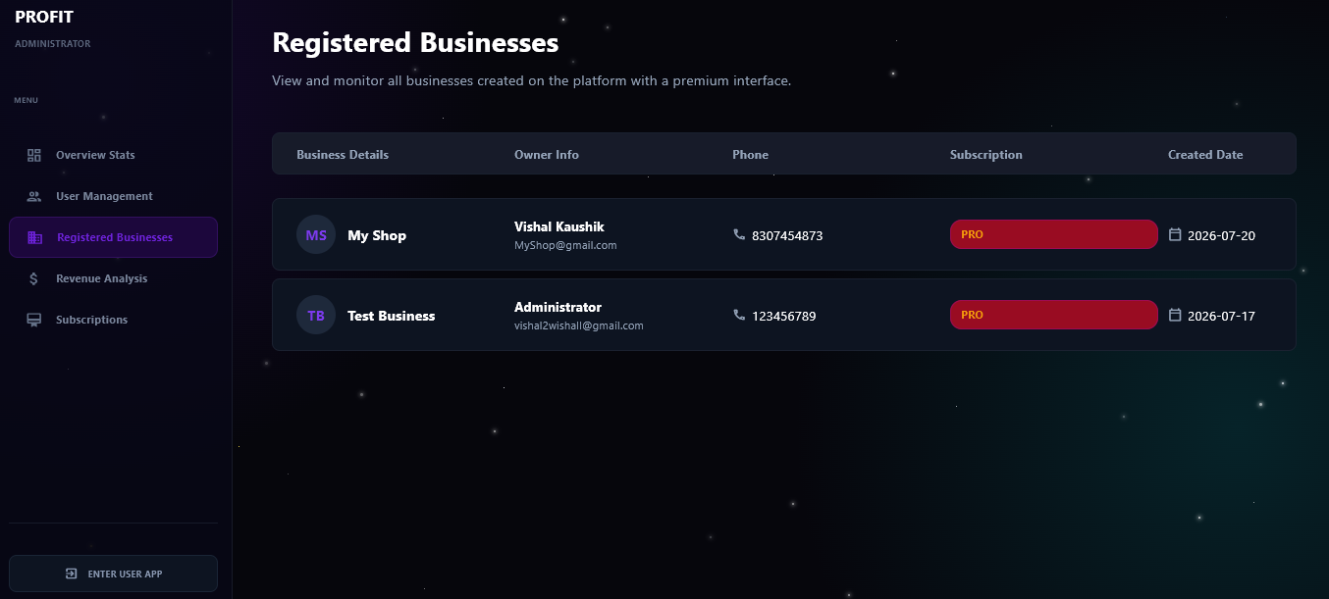

2.4.23 Revenue Analytics
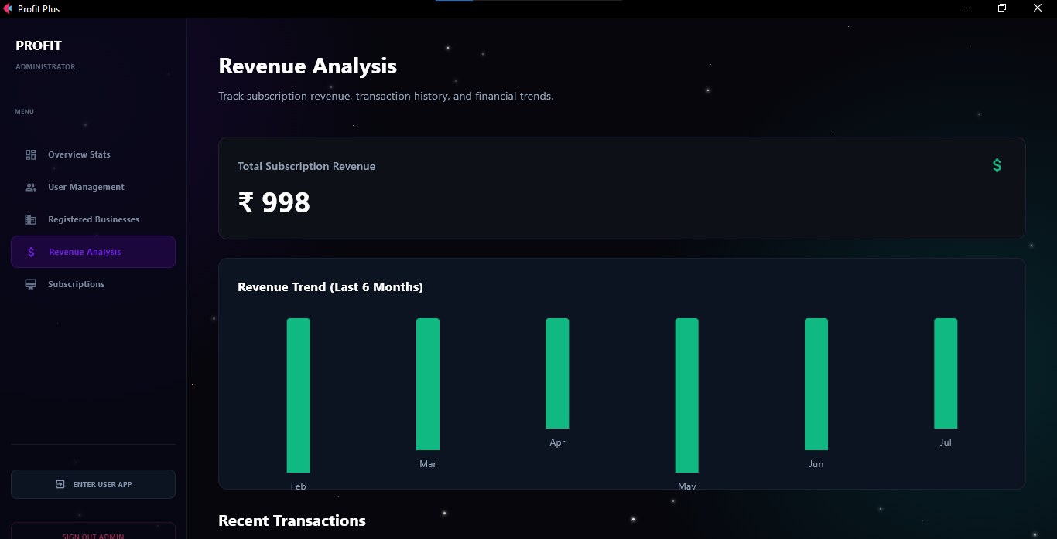
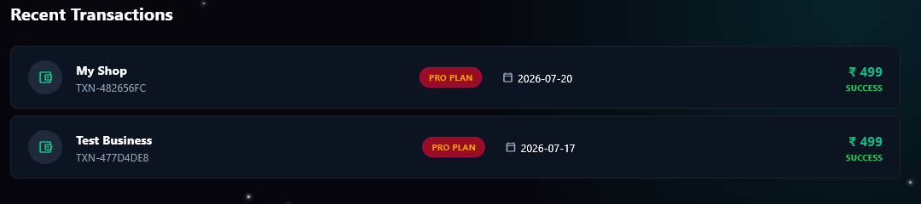

2.4.24 Subscription Management
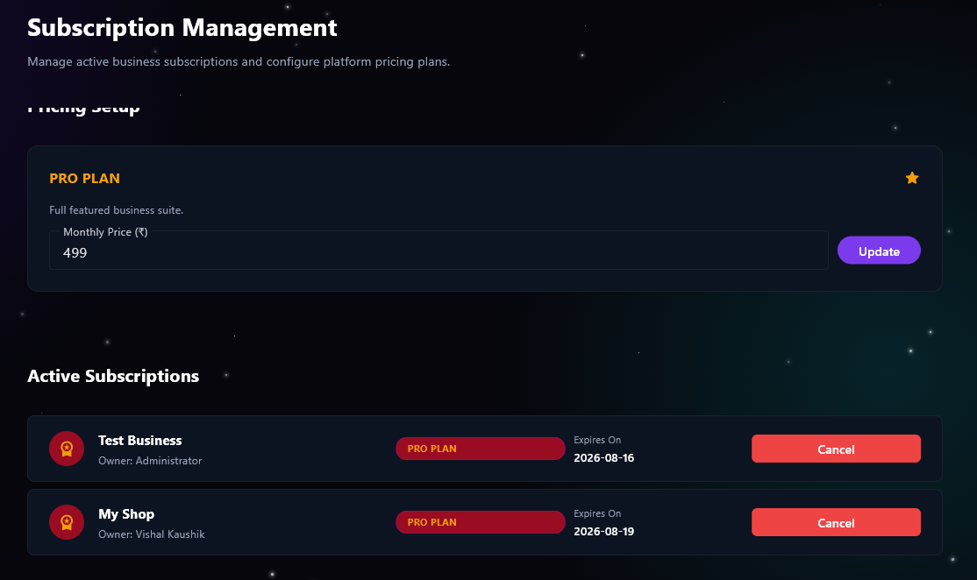

Managing Platform Subscriptions and Pricing
This screenshot shows the Subscription Management screen. This is the financial control center for the Super Admin who owns the Profit Plus platform.
- Pricing Setup (Top Section): This is a very powerful feature for a software business. Instead of the monthly price being permanently fixed, the platform owner can dynamically change the cost of the "PRO PLAN" right here. If they want to raise the price from ₹499 to ₹599, they just type the new number and click the purple "Update" button. This instantly updates the pricing page across the entire app for any new users looking to upgrade!
- Active Subscriptions (Bottom Section): This acts as a live billing ledger. It lists every single shop that is currently paying for the premium service. You can clearly see our example stores ("Test Business" and "My Shop") along with the exact date their current billing cycle expires.
- The Cancel Button: On the far right of each active user, there is a prominent red "Cancel" button. If a store owner reaches out to cancel their service, or if there is an issue with their payment, the admin can click this to instantly revoke their Pro status.

2.5 Test Table

Test ID | Module | Test Scenario | Expected Result
TC-01 | Authentication | User Registration (OTP): Submit a new account form with a valid email and phone number. | System should generate and send an OTP to the email. Account is only created upon successful OTP entry.
TC-02 | Authentication | User Login: Attempt to log in with correct email/password credentials. | System authenticates the user, generates a secure session, and redirects to the Shop Manager Dashboard.
TC-03 | Multi-Tenancy | Create Business: Fill out the 'Create Business' form with commercial, contact, and address details. | A new shop profile is created in the database, uniquely linked to the logged-in user, keeping data isolated.
TC-04 | Inventory | Restock Product: Add 10 units of 'Samsung S24 Ultra' and set a minimum stock alert of 2. | Inventory database updates to 10 units. System will trigger a low-stock warning when quantity drops to 2.
TC-05 | Billing | Standard Checkout: Add an item to the cart, fill out customer details, and finalize the bill. | Invoice is generated, total revenue updates on the dashboard, and the item is immediately deducted from live inventory.
TC-06 | Billing (EMI) | EMI Calculator: Select 'Purchase on EMI', enter a down payment, an 8% interest rate, and a 24-month tenure. | System accurately calculates the exact Expected Monthly EMI and creates a new active contract in the customer's profile.
TC-07 | Subscriptions | Upgrade to Pro: Click 'Upgrade to Pro' from a free starter account and simulate payment. | Account status updates to PRO, and the locked 'Analytics' tab instantly becomes accessible to the user.
TC-08 | Analytics | Profit Calculation: Process a sale where the item was purchased for ₹100,000 and sold for ₹120,000. | The BI Terminal accurately reflects ₹120,000 in Gross Sales and exactly ₹20,000 in Pure Profit.
TC-09 | Super Admin | Lock User Account: Admin clicks the red 'Lock' button next to an active user in the directory. | The user's active session is terminated, and they are blocked from logging in until the admin unlocks the account.
TC-10 | Super Admin | Dynamic Pricing Update: Admin changes the Pro Plan price from ₹499 to ₹599 and clicks Update. | The master pricing updates immediately. Any free user looking to upgrade will now see the new ₹599 price tag.

2.6 Applications of the Project
- Running a SaaS Startup (Software as a Service): The biggest application of this project is that it is built to be a business in itself! Because of the Super Admin dashboard and subscription system, you can launch this software online and charge other shop owners a monthly fee (like that ₹499/month Pro plan) to use your platform to run their stores.
- Local Retail & Electronics Stores: It is a perfect fit for independent shop owners. Whether they sell mobile phones, laptops, or home appliances, they can use this as their everyday digital cash register to print invoices, track GST, and see exactly how much stock is left on the back shelves.
- Managing Customer Credit & EMIs: A lot of local businesses run on trust and give items out on credit or monthly installments. Instead of writing all this down in a physical notebook that can get lost, shop owners can use the app to automatically track down payments, interest rates, and exactly who owes them money and when it is due.
- Business Intelligence for Small Shops: Most small business owners just guess at how much money they are actually taking home at the end of the month. This app gives them a professional analytics dashboard so they can instantly see their pure profit, their best-selling items, and any dead stock that is just taking up space.
- Customer Relationship Management (CRM): It acts as a digital phonebook for the store. Whenever someone buys something, their details and purchase history are saved. The shop owner can see a customer's "Lifetime Value," which makes handling warranty claims, returns, or even sending out holiday discounts incredibly easy.

3. Conclusion
In conclusion, Profit Plus is much more than just a standard billing application; it is a fully functioning Software-as-a-Service (SaaS) platform built for the real world.
The core achievement of this project is how it simplifies complex business operations. By combining live inventory tracking, built-in EMI calculators, and automated tax reporting, it takes the manual heavy lifting out of running a daily storefront. For the individual shop owner, the business intelligence and analytics tools provide absolute clarity on their financial health, profits, and customer relationships without requiring them to be financial experts.
Equally important is the robust backend architecture that powers the platform. The multi-tenant design successfully ensures that multiple different businesses can operate on the same software with complete data privacy and security. Furthermore, the Super Admin dashboard proves that the platform is fully monetizable, giving the creator complete control over user management, active subscriptions, and dynamic pricing.

4. Reference and Bibliography
• Flet: https://flet.dev/
• FastAPI: https://fastapi.tiangolo.com/
• PostgreSQL: https://www.postgresql.org/docs/
• Python: https://docs.python.org/3/
• Razorpay API: https://razorpay.com/docs/
• Microsoft Azure Multi-tenant Patterns: https://learn.microsoft.com/en-us/azure/architecture/guide/multitenant/overview

